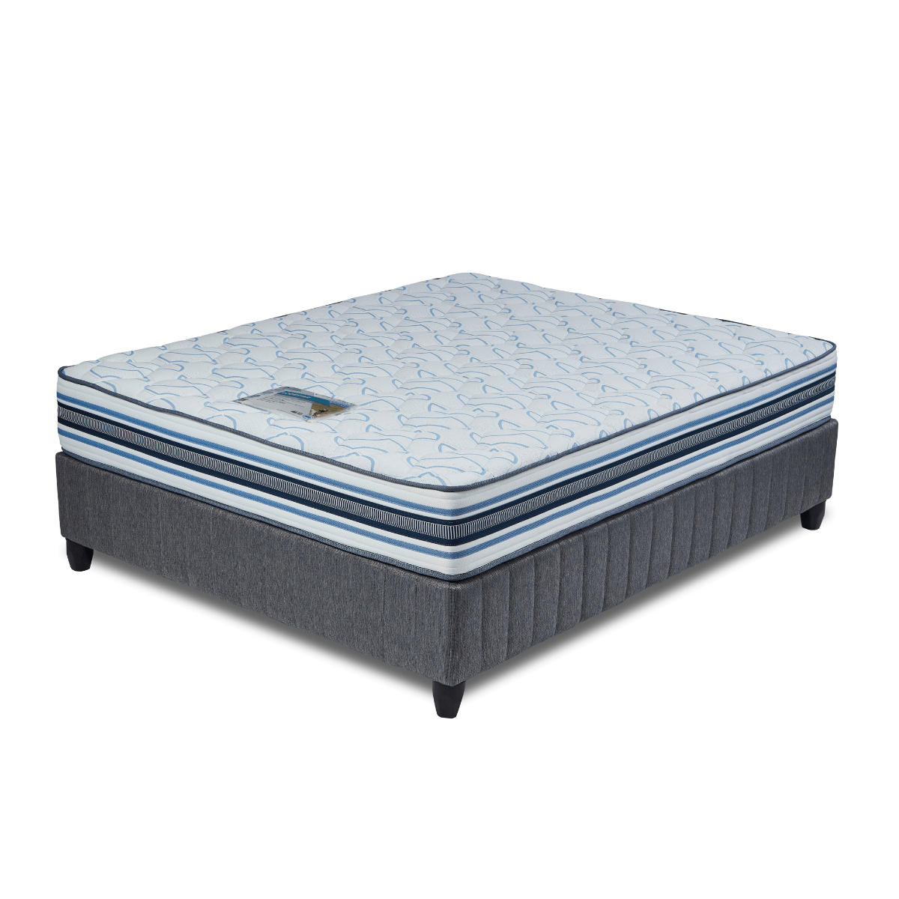


Model : Lodestar Bed Set
Supplier/Manufacturer : Cloud Nine
Range : Premium
Prices – Bed Set :
- Single Bed Set – R8159
- Three Quarter Bed Set – R9339
- Double Bed Set – R11359
- Queen Bed Set – R12389
- King Bed Set – R15539
Prices – Mattress Only :
- Single Mattress Only – R6499
- Three Quarter Mattress Only – R7509
- Double Mattress Only – R9339
- Queen Mattress Only – R10309
- King Mattress Only – R12229
Prices - Extra Length Bed Set :
- Single Extra Length Bed Set – R8819
- Three Quarter Extra Length Bed Set – R10089
- Double Extra Length Bed Set – R12269
- Queen Extra Length Bed Set – R13379
- King Extra Length Bed Set – R16789
Prices - Extra Length Mattress Only :
- Single Extra Length Mattress Only – R7019
- Three Quarter Extra Length Mattress Only – R8109
- Double Extra Length Mattress Only – R10089
- Queen Extra Length Mattress Only – R11139
- King Extra Length Mattress Only – R13209

*Please use this link for guideline for creating the page* - https://www.bedsonline.co.za/product/cloud-nine-lodestar-queen/
Cloud Nine Link - https://cloudnine.co.za/beds/premium/lodestar/

